DAY 18 – 06.05.2024 ER DIAGRAM SCREENSHOT

QUESTION 1

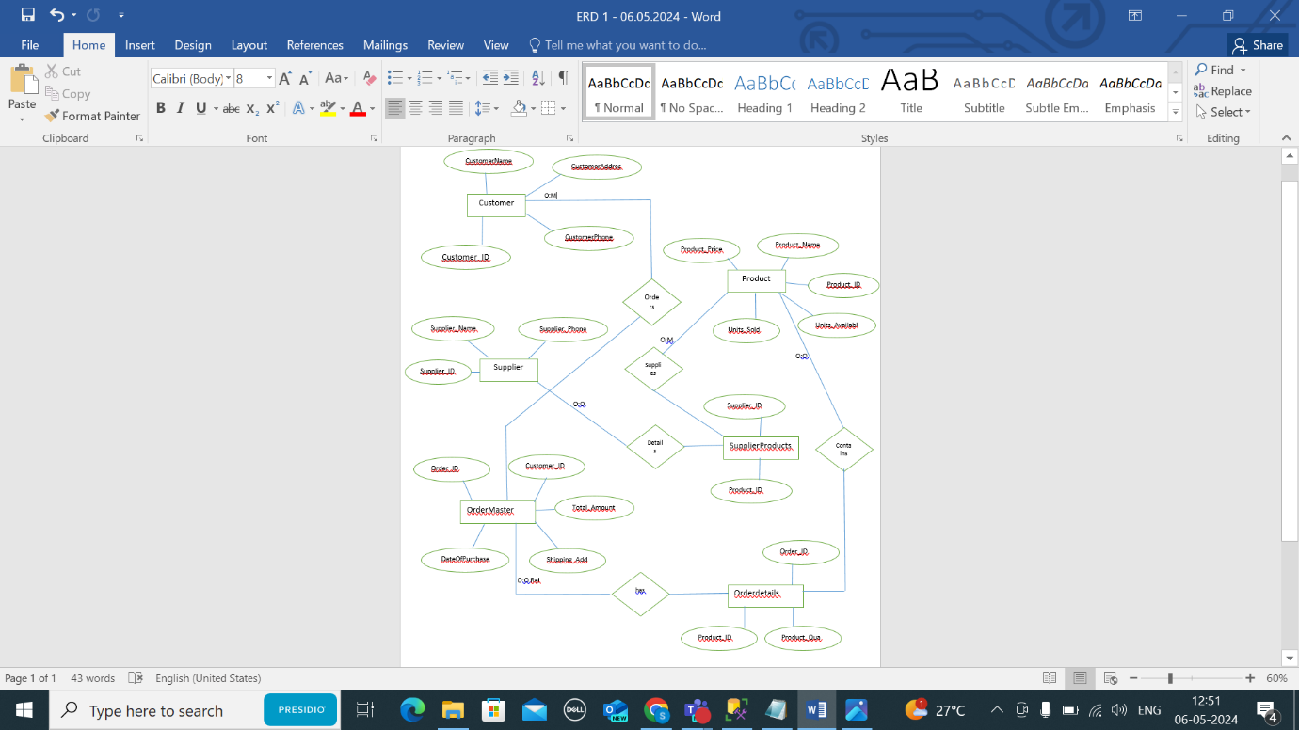

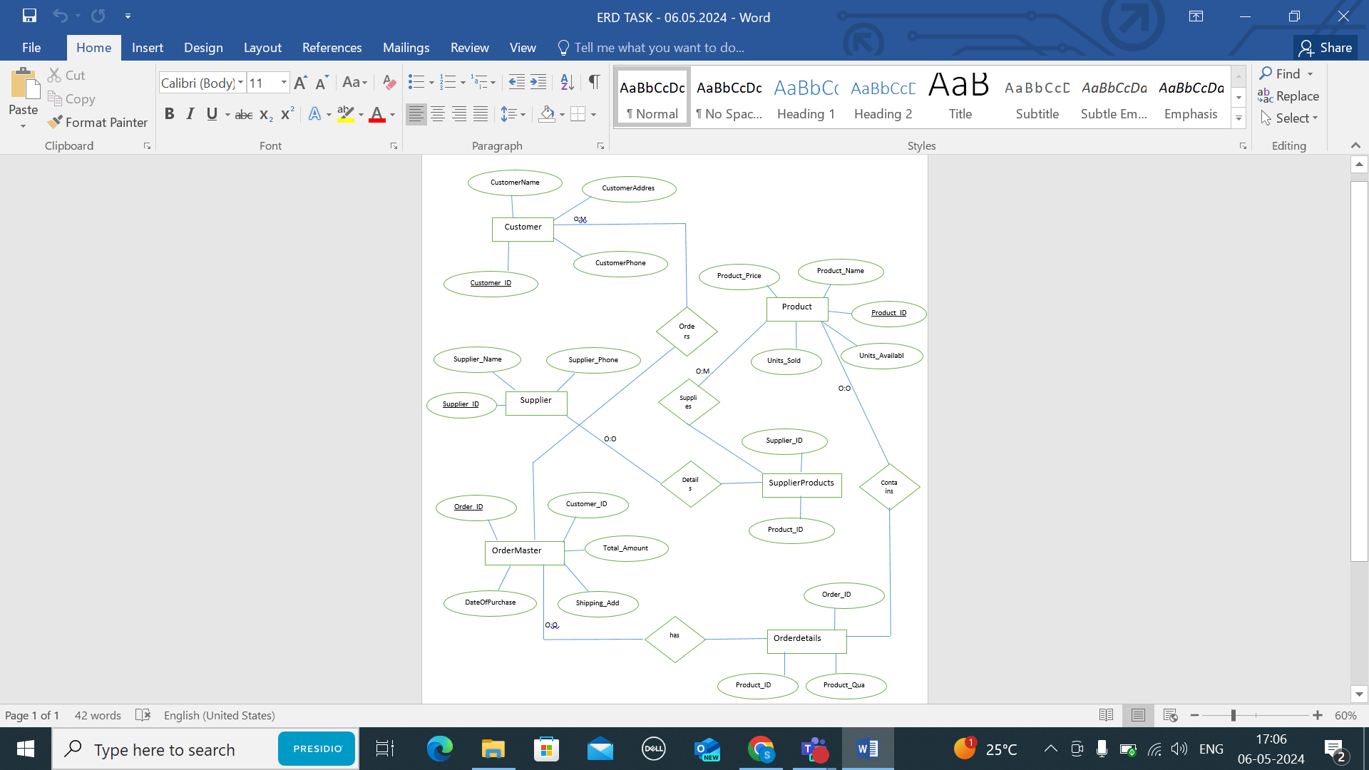

QUESTION 2

